**ETHEREUM SMART CONTRACT DEMO**

**Aryan Nava Token(ARN)**

**The official token symbol for Aryan Nava Token : ARN**

**Token Type: ERC20**

**Decimals allowed : 18**

**ARN Coinig Total Supply : 200,000,000**

**Price : 1ETH = 100ARN Tokens Deployment and Testing of Ethereum Smart Contract**

**Method:** MetaMask Plugin

**Platform:** Remix.ethereum.org

**Test setup:** Rinkeby Test Network

**Process:**

**Step 1:** Browse <https://remix.ethereum.org/> click on the top left button “+” a new file will be created enter the new file name as shown below

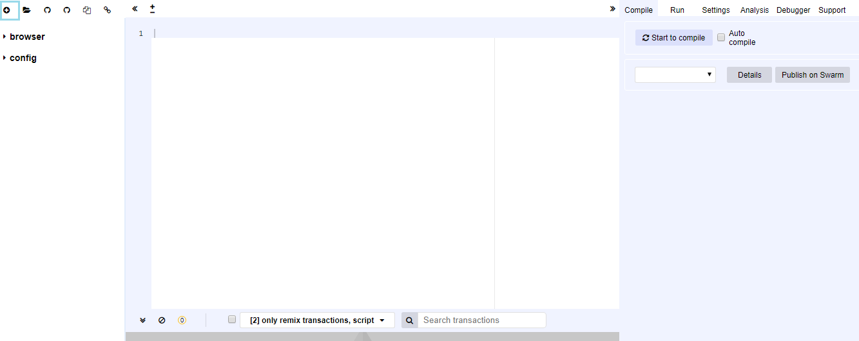

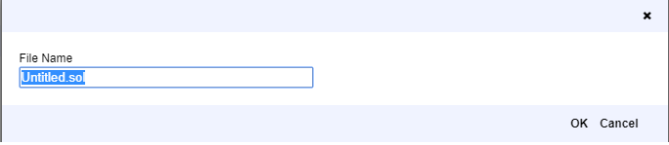

**Step 2:** Copy the code solidity code from file :“ ARN_Crowdsale.sol ” and paste it in <https://remix.ethereum.org> as shown below.

Under the Compile tab, click on start to compile to successfully complete the compilation process as shown below.

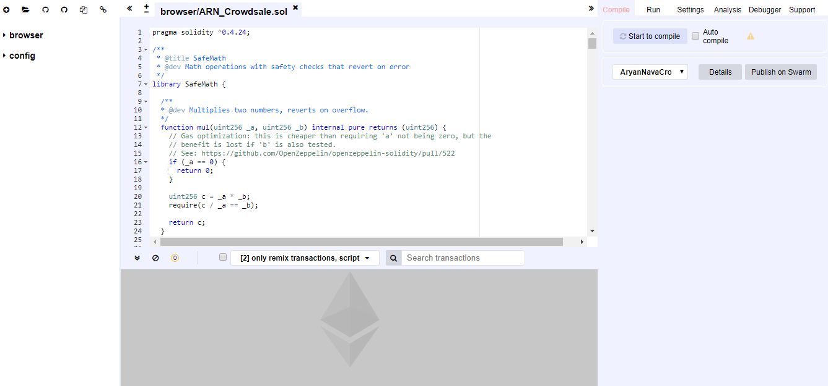

**Step 3:** Click on Run and set Environment and account address as shown in the image below.

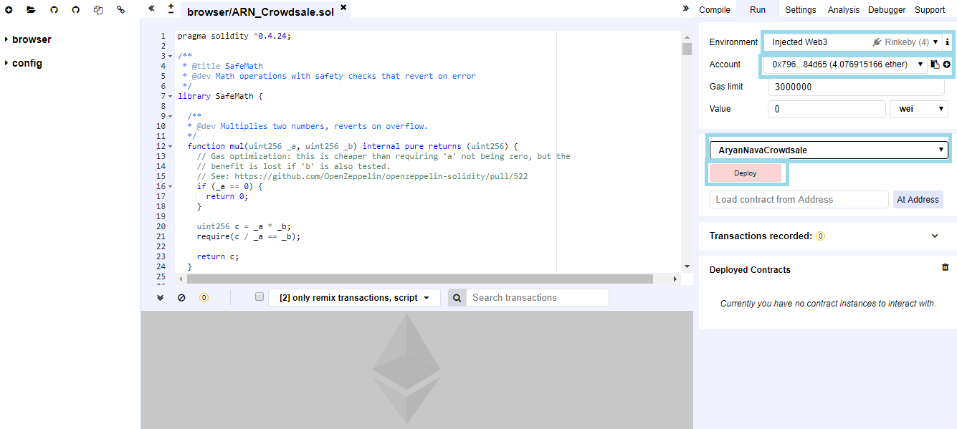

Make sure that the Wallet address in Metamask and remix IDE is same while deploying a Contract as shown below

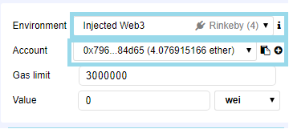 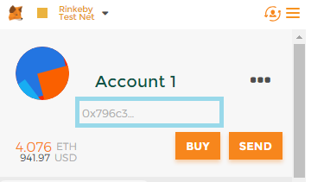

**Step 4:** Click on Deploy button under the Run tab and click on the submit tab in the new popup transaction window, so contract is started to deploy

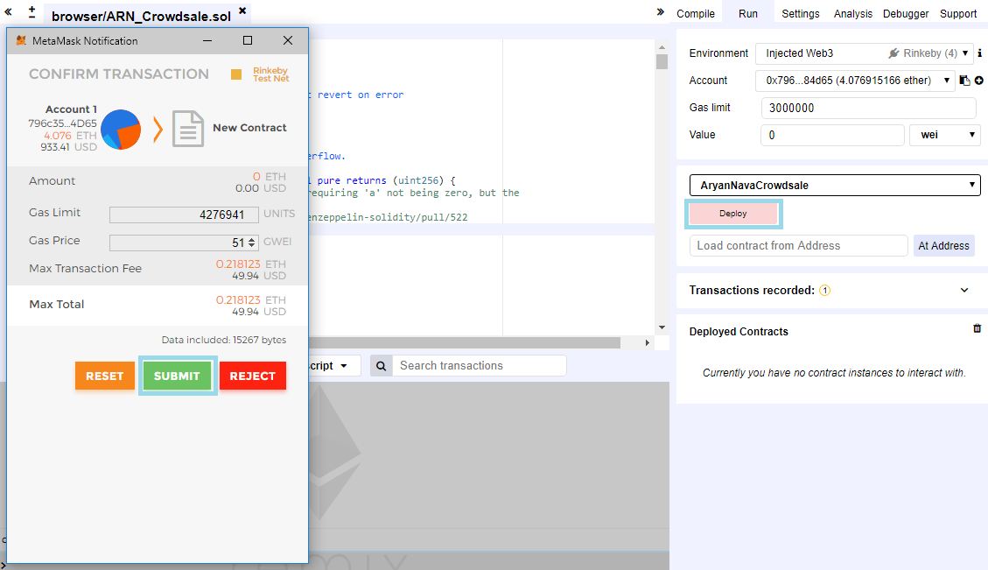

**Step 5**: Once the contract is Deployed , a list of contract functionalities in the right bottom corner as shown below.

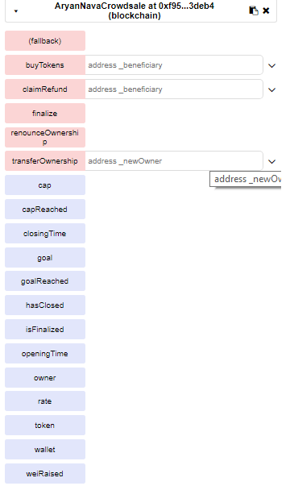

**Step 6:** To Confirm the Transaction is successful click on the rinkeby.etherscan.io link which will redirect to a etherscan page as shown below

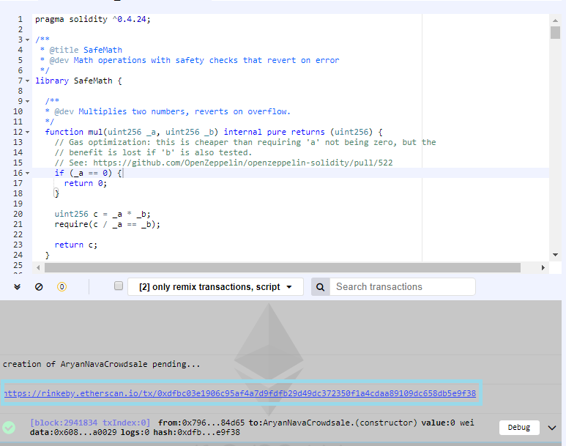 **(OR)** 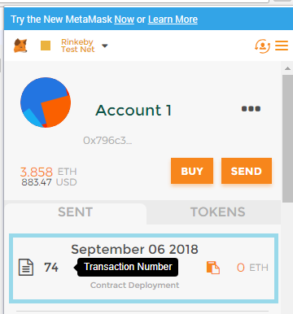



**Transaction Hash ,Transaction Status, Contract Address,Gas Price are displayed as shown below**

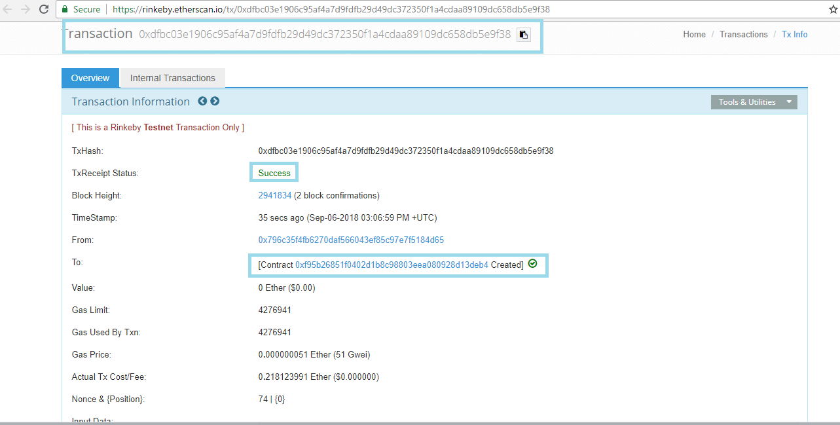**Test Scenarios to Buy Tokens:**

1. **Transferring Ethers from wallet Account (address) to owner account(contract Account).**

**Step 1**: Browse to Account 1 and click on the **SEND** button to send some Ethers to Owner Account.

**Step 2**: Enter the **Contract address** , Enter the number of Ethers to send and click on **NEXT** button which will redirect to Transaction Confirmation window click on **SUBMIT** button .

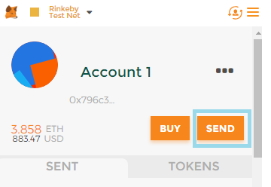 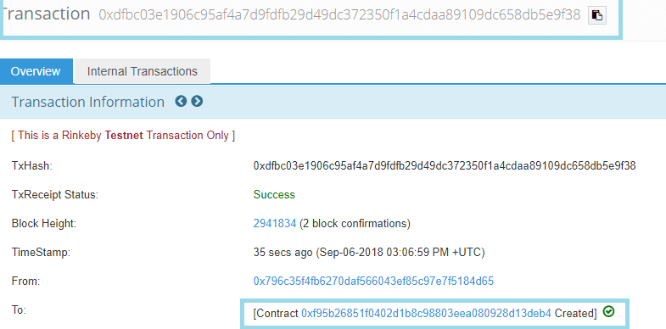

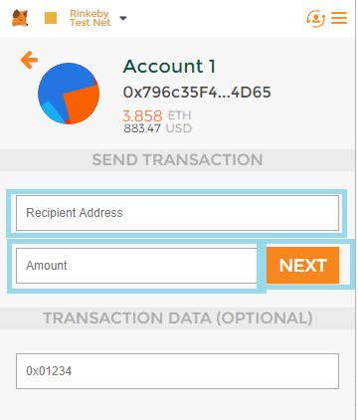 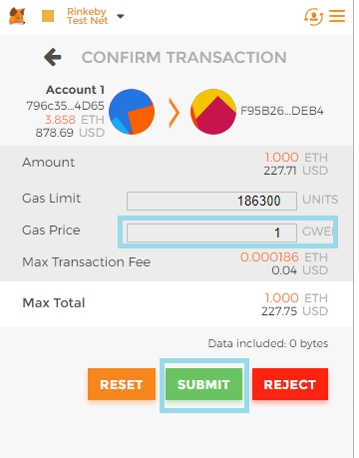

**Step 3:** Once the transaction is successful, To confirm browse to rinkeby.etherscan.io and check the Transaction Status.

To view the ERC20 Token Contract address click on the ERC20(ARN) will redirect to a ERC20 Token Page as shown below

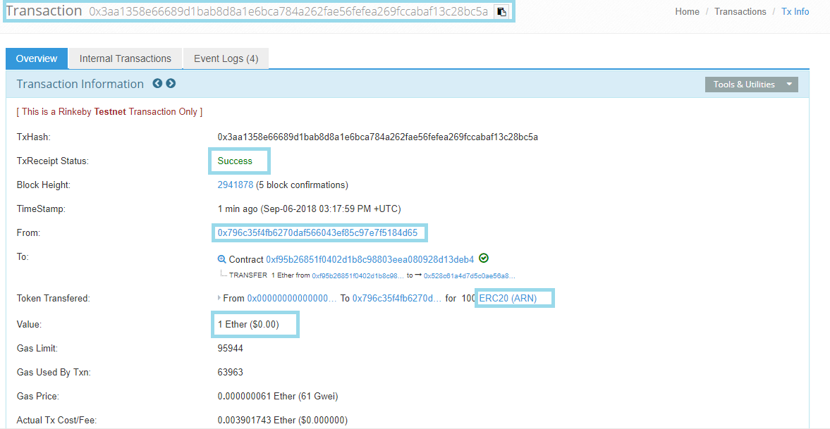

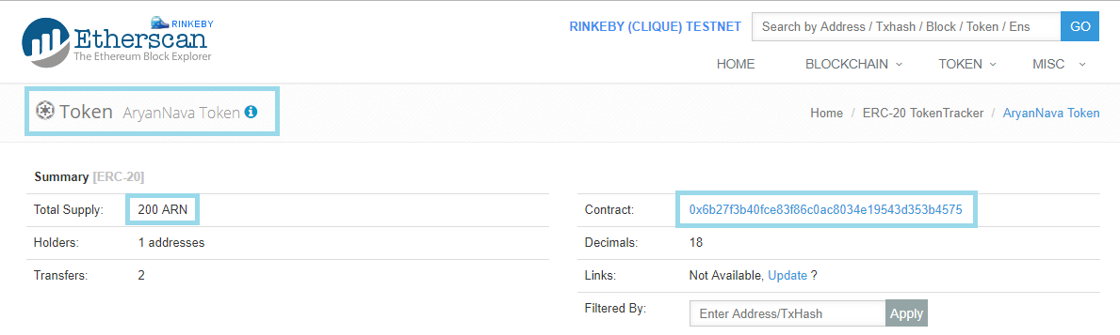

**Step 5:** To view the Tokens Browse to Metamask and select **Account 1 Wallet** Click on **ADD TOKEN** which will redirect to add another tab Enter the **contract address**(Contract address is ERC20 Token address as shown above image) ,Automatically Token symbol will be replaced with **“ARN”** and click on **Add** button then the number of Tokens are present in Account 1 are displayed. Refer below diagrams

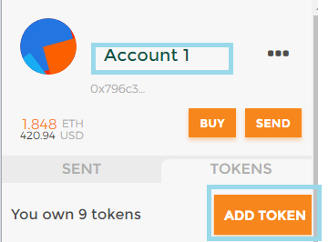 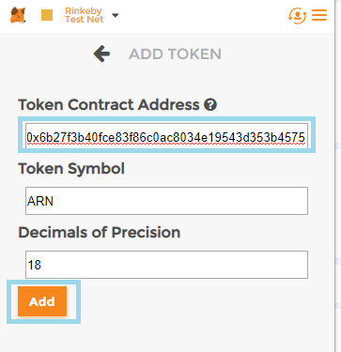 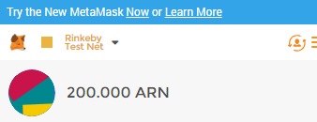

Note : Other Functionalities of ICO

